***Лабораторна робота №4***

***Хід роботи:***

***Завдання на лабораторну роботу:***

1. ***Завдання на лабораторну роботу:***



***Виконання:***

* ***HTML:***

<!DOCTYPE *html*>  
<html *lang*="en">  
<head>  
 <meta *charset*="UTF-8">  
 <title>Task 1</title>  
 <link *rel*="stylesheet" *href*="./styles/css/task_1.css">  
 <link *rel*="icon" *href*="../../../../img/icons/racoon_animal_icon_123571.ico">  
</head>  
<body>  
<div *class*="wrapper">  
 <div *class*="container">  
 <section *class*="button_section">  
 <table *class*="button_section__table">  
 <tr>  
 <td>  
 <label *for*="imgRaccoon1" *class*="table__label_img">First image:</label>  
 </td>  
 <td>  
 <img *src*="./img/raccoon(1).png" *alt*="raccoon(1)" *class*="table__img" *id*="imgRaccoon1">  
 </td>  
 </tr>  
 <tr>  
 <td *colspan*="2">  
 <div *class*="table__div_raccoon_1_src"></div>  
 </td>  
 </tr>  
 <tr>  
 <td>  
 <label *for*="imgRaccoon2" *class*="table__label_img">Second image:</label>  
 </td>  
 <td>  
 <img *src*="./img/raccoon(2).png" *alt*="raccoon(2)" *class*="table__img" *id*="imgRaccoon2">  
 </td>  
 </tr>  
 <tr>  
 <td *colspan*="2">  
 <div *class*="table__div_raccoon_2_src"></div>  
 </td>  
 </tr>  
 <tr>  
 <td>  
 <label *for*="imgRaccoon3" *class*="table__label_img">Third image:</label>  
 </td>  
 <td>  
 <img *src*="./img/raccoon(3).png" *alt*="raccoon(3)" *class*="table__img" *id*="imgRaccoon3">  
 </td>  
 </tr>  
 <tr>  
 <td *colspan*="2">  
 <div *class*="table__div_raccoon_3_src"></div>  
 </td>  
 </tr>  
 <tr>  
 <td>  
 <label *for*="imgRaccoon4" *class*="table__label_img">Fourth image:</label>  
 </td>  
 <td>  
 <img *src*="./img/raccoon(4).png" *alt*="raccoon(4)" *class*="table__img" *id*="imgRaccoon4">  
 </td>  
 </tr>  
 <tr>  
 <td *colspan*="2">  
 <div *class*="table__div_raccoon_4_src"></div>  
 </td>  
 </tr>  
 </table>  
 </section>  
 </div>  
  
 <script *src*="./js/task_1.js"></script>  
</div>  
</body>  
</html>

* ***SASS:***

*  
 margin: 0  
 padding: 0  
 box-sizing: border-box  
  
.*wrapper* width: 100%  
 height: 100vh  
 display: flex  
 align-items: center  
 flex-direction: column  
  
.*button_section* border: 2px solid black  
 margin: 10px 0  
 padding: 10px  
 max-width: 40vw  
  
.*button_section__table* border-collapse: collapse  
  
.*table__img* width: 200px  
 margin-left: 10px  
  
.*table__div_raccoon_1_src*, .*table__div_raccoon_2_src*, .*table__div_raccoon_3_src*, .*table__div_raccoon_4_src* border: 1px solid darkgrey  
 padding: 5px

* ***JS:***

'use strict';  
  
*const* raccoonImages = document.querySelectorAll('.table__img');  
*for* (*let* i = 0; i < raccoonImages.length; i++) {  
 raccoonImages[i].addEventListener('click', (event) => {  
 *const* imgIndex = i + 1  
 console.log(imgIndex);  
 *const* outputDiv = document.querySelector(`.table__div_raccoon_${imgIndex}_src`);  
 console.log(event.target.src);  
 console.log(outputDiv);  
 outputDiv.innerHTML = `<p>Img source: ${event.target.src}</p>`;  
 })  
}

***Результат програми:***

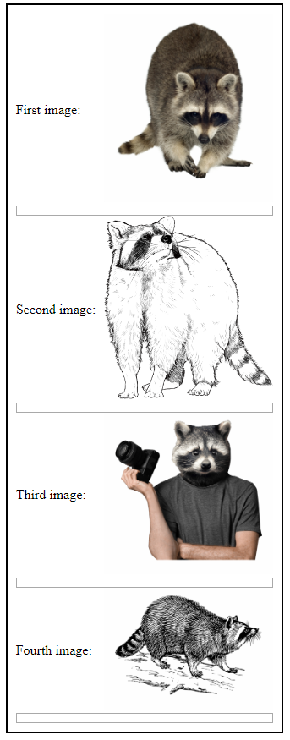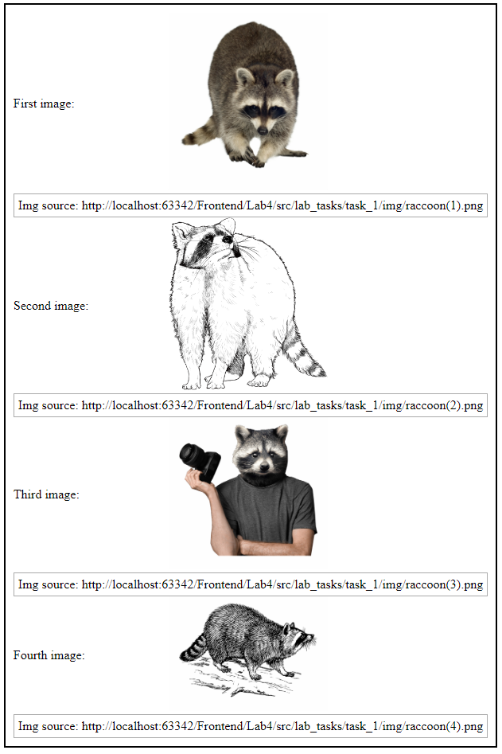



***Виконання:***

* ***HTML:***

<!DOCTYPE *html*>  
<html *lang*="en">  
<head>  
 <meta *charset*="UTF-8">  
 <title>Task 2</title>  
 <link *rel*="stylesheet" *href*="./styles/css/task_2.css">  
 <link *rel*="icon" *href*="../../../../img/icons/racoon_animal_icon_123571.ico">  
</head>  
<body>  
<div *class*="wrapper">  
 <div *class*="container">  
 <section *class*="button_section">  
 <table *class*="button_section__table">  
 <tr>  
 <td>  
 <label *for*="paragraph_one" *class*="table__label_paragraph">Paragraph 1:</label>  
 </td>  
 <td>  
 <p *id*="paragraph_one" *class*="table__paragraph"></p>  
 </td>  
 </tr>  
 <tr>  
 <td>  
 <label *for*="paragraph_two" *class*="table__label_paragraph">Paragraph 2:</label>  
 </td>  
 <td>  
 <p *id*="paragraph_two" *class*="table__paragraph"></p>  
 </td>  
 </tr>  
 <tr>  
 <td>  
 <label *for*="paragraph_three" *class*="table__label_paragraph">Paragraph 3:</label>  
 </td>  
 <td>  
 <p *id*="paragraph_three" *class*="table__paragraph"></p>  
 </td>  
 </tr>  
 <tr>  
 <td>  
 <label *for*="paragraph_four" *class*="table__label_paragraph">Paragraph 4:</label>  
 </td>  
 <td>  
 <p *id*="paragraph_four" *class*="table__paragraph"></p>  
 </td>  
 </tr>  
 </table>  
 </section>  
 </div>  
  
 <script *src*="./js/task_2.js"></script>  
</div>  
</body>  
</html>

* ***SASS:***

*  
 margin: 0  
 padding: 0  
 box-sizing: border-box  
  
.*wrapper* width: 100%  
 height: 100vh  
 display: flex  
 align-items: center  
 flex-direction: column  
  
.*button_section* border: 2px solid black  
 margin: 10px 0  
 padding: 10px  
 max-width: 30vw  
  
.*button_section__table* border-collapse: collapse  
  
.*table__paragraph* margin: 5px 0 5px 10px  
 cursor: pointer

* ***JS:***

'use strict';  
  
*const getRandomInt*= (*fromNumber*, *toNumber*) => Math.round((Math.random() * (*toNumber* -  
 *fromNumber*) + *fromNumber*));  
  
*const* paragraphs = document.querySelectorAll('.*table__paragraph*');  
*for* (*let* i = 0; i < paragraphs.length; i++) {  
 *const* generatedNumber = *getRandomInt*(-10, 10);  
 paragraphs[i].innerHTML = `${generatedNumber}`;  
 paragraphs[i].setAttribute('value', generatedNumber.toString())  
 paragraphs[i].addEventListener('click', (*event*) => {  
 *const* number = *parseInt*(*event*.target.getAttribute('value')) ** 2;  
 paragraphs[i].setAttribute('value', number.toString())  
 paragraphs[i].innerHTML = `${number}`;  
 });  
}

***Результат програми:***

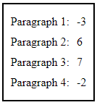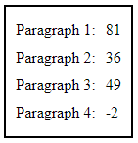

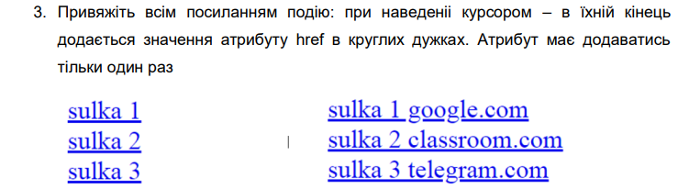

***Виконання:***

* ***HTML:***

<!DOCTYPE *html*>  
<html *lang*="en">  
<head>  
 <meta *charset*="UTF-8">  
 <title>Task 3</title>  
 <link *rel*="stylesheet" *href*="./styles/css/task_3.css">  
 <link *rel*="icon" *href*="../../../../img/icons/racoon_animal_icon_123571.ico">  
</head>  
<body>  
<div *class*="wrapper">  
 <div *class*="container">  
 <section *class*="button_section">  
 <table *class*="button_section__table">  
 <tr>  
 <td>  
 <label *for*="aLinkOne" *class*="table__label_link">First link:</label>  
 </td>  
 <td>  
 <a *id*="aLinkOne" *href*="https://github.com/AndriiBabushko/Frontend" *class*="table__link" *title*="GitHub" *value*="LINK">LINK</a>  
 </td>  
 </tr>  
 <tr>  
 <td>  
 <label *for*="aLinkTwo" *class*="table__label_link">Second link:</label>  
 </td>  
 <td>  
 <a *id*="aLinkTwo" *href*="https://www.youtube.com/watch?v=ywtqzPVIfx0" *class*="table__link" *title*="Youtube" *value*="LINK">LINK</a>  
 </td>  
 </tr>  
 <tr>  
 <td>  
 <label *for*="aLinkThree" *class*="table__label_link">Third link:</label>  
 </td>  
 <td>  
 <a *id*="aLinkThree" *href*="https://developer.mozilla.org/en-US/" *class*="table__link" *title*="MDN" *value*="LINK">LINK</a>  
 </td>  
 </tr>  
 </table>  
 </section>  
 </div>  
  
 <script *src*="./js/task_3.js"></script>  
</div>  
</body>  
</html>

* ***SASS:***

*  
 margin: 0  
 padding: 0  
 box-sizing: border-box  
  
.*wrapper* width: 100%  
 height: 100vh  
 display: flex  
 align-items: center  
 flex-direction: column  
  
.*button_section* border: 2px solid black  
 margin: 10px 0  
 padding: 10px  
 max-width: 30vw  
  
.*button_section__table* border-collapse: collapse  
  
.*table__link* margin: 5px 0 5px 10px

* ***JS:***

'use strict';  
  
*const* links = document.querySelectorAll('.*table__link*');  
*for* (*let* i = 0; i < links.length; i++) {  
 links[i].addEventListener('mouseover', (*event*)=> {  
 *const* target = *event*.target;  
 *const* link = target.getAttribute('href');  
 *const* value = target.getAttribute('value');  
 *const* splitLink = link.split(/\/\/|\//);  
 links[i].innerHTML = `${value} ${splitLink[1]}`;  
 });  
}

***Результат програми:***

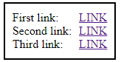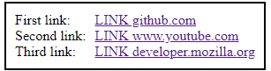

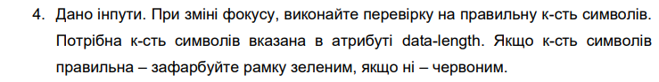

***Виконання:***

* ***HTML:***

<!DOCTYPE *html*>  
<html *lang*="en">  
<head>  
 <meta *charset*="UTF-8">  
 <title>Task 4</title>  
 <link *rel*="stylesheet" *href*="./styles/css/task_4.css">  
 <link *rel*="icon" *href*="../../../../img/icons/racoon_animal_icon_123571.ico">  
</head>  
<body>  
<div *class*="wrapper">  
 <div *class*="container">  
 <section *class*="button_section">  
 <table *class*="button_section__table">  
 <tr>  
 <td>  
 <label *for*="textFirstInput" *class*="table__label_text">First input:</label>  
 </td>  
 <td>  
 <input *type*="text" *name*="textFirstInput" *id*="textFirstInput" *class*="table__text" *placeholder*="First text" *data-length*="10">  
 </td>  
 </tr>  
 <tr>  
 <td>  
 <label *for*="textSecondInput" *class*="table__label_text">Second input:</label>  
 </td>  
 <td>  
 <input *type*="text" *name*="textSecondInput" *id*="textSecondInput" *class*="table__text" *placeholder*="Second text input" *data-length*="20">  
 </td>  
 </tr>  
 <tr>  
 <td>  
 <label *for*="textThirdInput" *class*="table__label_text">Third input:</label>  
 </td>  
 <td>  
 <input *type*="text" *name*="textThirdInput" *id*="textThirdInput" *class*="table__text" *placeholder*="Third" *data-length*="5">  
 </td>  
 </tr>  
 </table>  
 </section>  
 </div>  
  
 <script *src*="./js/task_4.js"></script>  
</div>  
</body>  
</html>

* ***SASS:***

*  
 margin: 0  
 padding: 0  
 box-sizing: border-box  
  
.*wrapper* width: 100%  
 height: 100vh  
 display: flex  
 align-items: center  
 flex-direction: column  
  
.*button_section* border: 2px solid black  
 margin: 10px 0  
 padding: 10px  
 max-width: 30vw  
  
.*button_section__table* border-collapse: collapse  
  
.*table__text* margin: 5px 0 5px 10px  
 height: 28px  
 border-style: solid

* ***JS:***

'use strict';  
  
*const* textInputs = document.querySelectorAll('.*table__text*');  
*for* (*let* i = 0; i < textInputs.length; i++) {  
 textInputs[i].addEventListener('focus', (*event*) => {  
 *const* dataLength = *parseInt*(textInputs[i].dataset.length);  
 *const* textInputValue = textInputs[i].value;  
  
 *if* (textInputValue.length <= dataLength) {  
 textInputs[i].style.borderColor = 'green';  
 textInputs[i].style.borderWidth = '3px';  
 } *else* {  
 textInputs[i].style.borderColor = 'red';  
 textInputs[i].style.borderWidth = '3px';  
 }  
 });  
}

***Результат програми:***

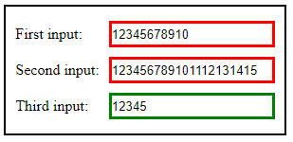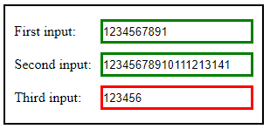

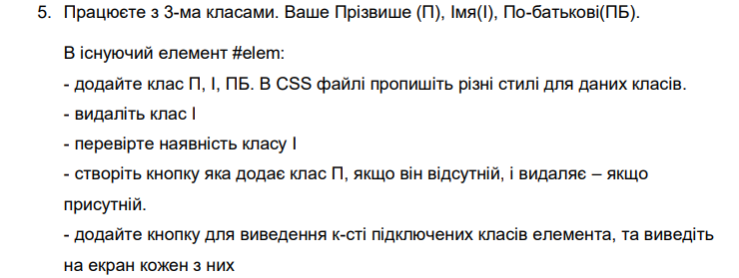

***Виконання:***

* ***HTML:***

<!DOCTYPE *html*>  
<html *lang*="en">  
<head>  
 <meta *charset*="UTF-8">  
 <title>Task 5</title>  
 <link *rel*="stylesheet" *href*="./styles/css/task_5.css">  
 <link *rel*="icon" *href*="../../../../img/icons/racoon_animal_icon_123571.ico">  
</head>  
<body>  
<div *class*="wrapper">  
 <div *class*="container">  
 <section *class*="button_section">  
 <table *class*="button_section__table">  
 <tr>  
 <td>  
 <label *for*="element" *class*="table__label_element">First text element:</label>  
 </td>  
 <td>  
 <p *id*="element" *class*="table__p_elem first_name last_name middle_name">Some text in first element</p>  
 </td>  
 </tr>  
 <tr>  
 <td *colspan*="2">  
 <input *type*="button" *value*="Add/remove first name class" *id*="buttonAddRemoveFirstName" *class*="table__button_add_remove_first_name">  
 </td>  
 </tr>  
 <tr>  
 <td *colspan*="2">  
 <input *type*="button" *value*="Add/remove last name class" *id*="buttonAddRemoveLastName" *class*="table__button_add_remove_last_name">  
 </td>  
 </tr>  
 <tr>  
 <td *colspan*="2">  
 <input *type*="button" *value*="Add/remove middle name class" *id*="buttonAddRemoveMiddleName" *class*="table__button_add_remove_middle_name">  
 </td>  
 </tr>  
 <tr>  
 <td *colspan*="2">  
 <input *type*="button" *value*="Check classes" *id*="buttonCheckClasses" *class*="table__button_check_classes">  
 </td>  
 </tr>  
 </table>  
 <div *class*="button_section__output_info" *id*="divOutputInfo"></div>  
 </section>  
 </div>  
  
 <script *src*="./js/task_5.js"></script>  
</div>  
</body>  
</html>

* ***SASS:***

*  
 margin: 0  
 padding: 0  
 box-sizing: border-box  
  
.*wrapper* width: 100%  
 height: 100vh  
 display: flex  
 align-items: center  
 flex-direction: column  
  
.*button_section* border: 2px solid black  
 margin: 10px 0  
 padding: 10px  
 max-width: 30vw  
  
.*button_section__table* border-collapse: collapse  
  
.*table__p_elem* margin: 10px 0 10px 10px  
 padding: 5px  
  
.*first_name* border: 1px solid red  
 color: red  
  
.*last_name* border: 1px solid green  
 color: green  
  
.*middle_name* border: 1px solid blue  
 color: blue  
  
.*table__button_add_remove_first_name*, .*table__button_add_remove_last_name*, .*table__button_add_remove_middle_name*, .*table__button_check_classes* width: 100%  
 height: 28px  
 font-style: italic  
  
.*button_section__output_info* border: 1px solid black  
 margin: 10px 0  
 text-align: center

* ***JS:***

'use strict';  
  
*const* element = document.querySelector('#element');  
*const* divOutputInfo = document.querySelector('#divOutputInfo');  
*const* buttonAddRemoveFirstName = document.querySelector('#buttonAddRemoveFirstName');  
*const* buttonAddRemoveLastName = document.querySelector('#buttonAddRemoveLastName');  
*const* buttonAddRemoveMiddleName = document.querySelector('#buttonAddRemoveMiddleName');  
*const* buttonCheckClasses = document.querySelector('#buttonCheckClasses');  
  
*const checkElementClass* = (*element*, *className*) => {  
 *if* (*element*.classList.contains(*className*)) {  
 console.log(`HAVE '${*className*}' CLASS!!!`);  
 *return true*;  
 }  
 console.log(`DON'T HAVE '${*className*}' CLASS!!!`);  
 *return false*;  
};  
  
buttonAddRemoveFirstName.addEventListener('click', () => {  
 *if* (*checkElementClass*(element, 'first_name')) {  
 element.classList.remove('first_name');  
 } *else* {  
 element.classList.add('first_name');  
 }  
});  
  
buttonAddRemoveLastName.addEventListener('click', () => {  
 *if* (*checkElementClass*(element, 'last_name')) {  
 element.classList.remove('last_name');  
 } *else* {  
 element.classList.add('last_name');  
 }  
});  
  
buttonAddRemoveMiddleName.addEventListener('click', () => {  
 *if* (*checkElementClass*(element, 'middle_name')) {  
 element.classList.remove('middle_name');  
 } *else* {  
 element.classList.add('middle_name');  
 }  
});  
  
buttonCheckClasses.addEventListener('click', () => {  
 divOutputInfo.innerHTML = '';  
 *if* (element.classList.contains('first_name'))  
 divOutputInfo.innerHTML += `<p>Elem HAS <strong>'first name'</strong> class!</p>`;  
 *else* divOutputInfo.innerHTML += `<p>Elem HASN'T <strong>'first name'</strong> class!</p>`;  
 *if* (element.classList.contains('last_name'))  
 divOutputInfo.innerHTML += `<p>Elem HAS <strong>'last name'</strong> class!</p>`;  
 *else* divOutputInfo.innerHTML += `<p>Elem HASN'T <strong>'last name'</strong> class!</p>`;  
 *if* (element.classList.contains('middle_name'))  
 divOutputInfo.innerHTML += `<p>Elem HAS <strong>'middle name'</strong> class!</p>`;  
 *else* divOutputInfo.innerHTML += `<p>Elem HASN'T <strong>'middle name'</strong> class!</p>`;  
});

***Результат програми:***

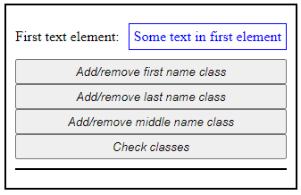

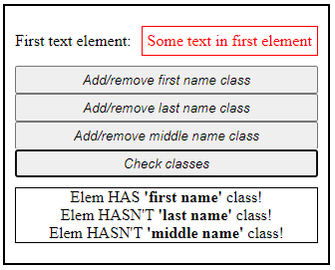

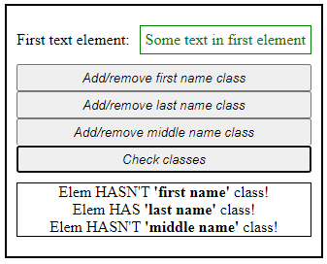

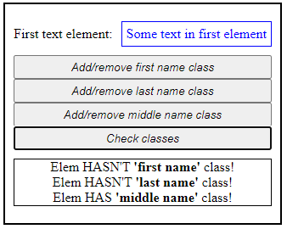

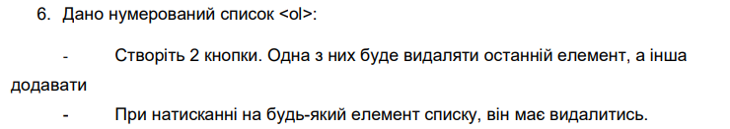

***Виконання:***

* ***HTML:***

<!DOCTYPE *html*>  
<html *lang*="en">  
<head>  
 <meta *charset*="UTF-8">  
 <title>Task 6</title>  
 <link *rel*="stylesheet" *href*="./styles/css/task_6.css">  
 <link *rel*="icon" *href*="../../../../img/icons/racoon_animal_icon_123571.ico">  
</head>  
<body>  
<div *class*="wrapper">  
 <div *class*="container">  
 <section *class*="button_section">  
 <table *class*="button_section__table">  
 <tr>  
 <td>  
 <label *for*="olList" *class*="table__label_ol_list" *id*="labelOlList">Ol elements list:</label>  
 </td>  
 </tr>  
 <tr>  
 <td>  
 <ol *class*="table__ol_list" *id*="olList">  
 <li *class*="ol_list__li_element">1</li>  
 <li *class*="ol_list__li_element">2</li>  
 <li *class*="ol_list__li_element">3</li>  
 <li *class*="ol_list__li_element">4</li>  
 <li *class*="ol_list__li_element">5</li>  
 </ol>  
 </td>  
 </tr>  
 <tr>  
 <td>  
 <input *type*="button" *value*="Add element to ol list" *id*="buttonAddElemList" *class*="table__button_add_elem_list">  
 </td>  
 </tr>  
 <tr>  
 <td>  
 <input *type*="button" *value*="Remove element from ol list" *id*="buttonRemoveElemList" *class*="table__button_remove_elem_list">  
 </td>  
 </tr>  
 </table>  
 </section>  
 </div>  
  
 <script *src*="./js/task_6.js"></script>  
</div>  
</body>  
</html>

* ***SASS:***

*  
 margin: 0  
 padding: 0  
 box-sizing: border-box  
  
.*wrapper* width: 100%  
 height: 100vh  
 display: flex  
 align-items: center  
 flex-direction: column  
  
.*button_section* border: 2px solid black  
 margin: 10px 0  
 padding: 10px  
 text-align: center  
  
.*button_section__table* border-collapse: collapse  
  
.*table__label_ol_list* font-size: 24px  
 font-weight: bold  
  
.*table__ol_list* display: flex  
 flex-direction: column  
 align-items: center  
  
.*ol_list__li_element* cursor: pointer  
  
.*table__button_add_elem_list*, .*table__button_remove_elem_list* margin: 10px 0  
 width: 100%  
 height: 28px

* ***JS:***

'use strict';  
  
*function removeItemFromArray*(*array*, *item*) {  
 *const* itemIndex = *array*.indexOf(*item*);  
  
 *if* (itemIndex > -1)  
 *array*.splice(itemIndex, 1);  
  
 *return array*;  
}  
  
*function addEventListenersToList*(*nodeList*, *elemsList*) {  
 *for* (*let* i = 0; i < *nodeList*.length; i++) {  
 *nodeList*[i].addEventListener('click', (*event*) => {  
 *const* target = *event*.target;  
 elemsList = removeItemFromArray(elemsList, target.textContent);  
 target.remove();  
 })  
 }  
}  
  
*const* buttonAddElemList = document.querySelector('#buttonAddElemList');  
*const* buttonRemoveElemList = document.querySelector('#buttonRemoveElemList');  
  
*const* olList = document.querySelector('#olList');  
*let* olListElements = document.querySelectorAll('.ol_list__li_element');  
  
*let* elemsList = []  
*for* (*let* i = 0; i < olListElements.length; i++) {  
 elemsList.push(olListElements[i].textContent);  
}  
  
buttonAddElemList.addEventListener('click', () => {  
 *const* element = document.createElement('li');  
 element.innerHTML = `${elemsList.length + 1}`;  
 element.classList.add('ol_list__li_element');  
  
 elemsList.push((elemsList.length + 1).toString());  
 olList.appendChild(element);  
  
 olListElements = document.querySelectorAll('.ol_list__li_element');  
 addEventListenersToList(olListElements, elemsList);  
});  
  
buttonRemoveElemList.addEventListener('click', () => {  
 olListElements[elemsList.length - 1].remove()  
 elemsList.pop();  
});

***Результат програми:***

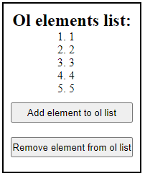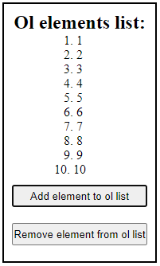

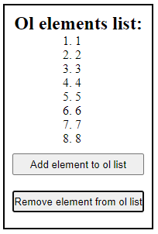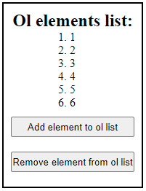

1. ***Домашнє завдання:***

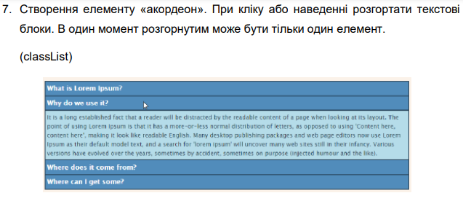

***Виконання:***

* ***HTML:***
* ***SASS:***
* ***JS:***

***Результат програми:***

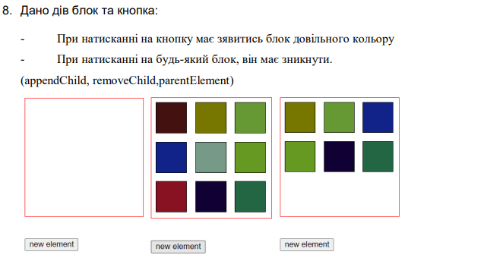

***Виконання:***

* ***HTML:***
* ***SASS:***
* ***JS:***

***Результат програми:***

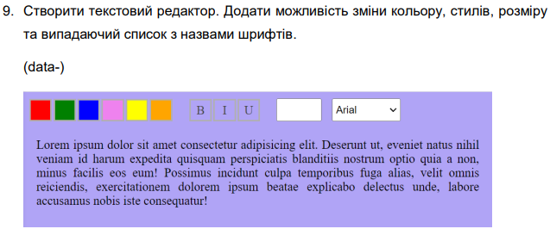

***Виконання:***

* ***HTML:***
* ***SASS:***
* ***JS:***

***Результат програми:***

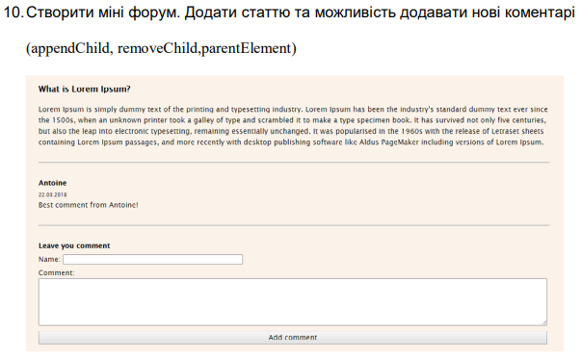

***Виконання:***

* ***HTML:***
* ***SASS:***
* ***JS:***

***Результат програми:***

***Репозиторій лабораторної роботи:***

* https://github.com/AndriiBabushko/Frontend

***Висновок:*** під час виконання лабораторної роботи було отримано навички обробки подій в мові JavaScript.